Table of Contents

Title and Abstract 2

Genetic algorithm and Memetic algorithm 3

Genetic algorithm 3

Memetic algorithm 3

Baldwinian effect and Lamarckian evolution 4

Contribution of this paper 5

Methods 5

Fitness function 5

Steady-state Genetic Algorithm 5

Crossover and Mutation operators of SSGA 10

Baldwin algorithm and Lamarck algorithm 12

Local search procedure 14

Results 14

Best 20 parameter combinations 14

Results of Experiments 16

Percentage of finding the global optimal value 16

Solutions analysis 16

Reference 25

# 

# Title and Abstract

**Title**: Comparing the Lamarckian and Baldwinian Approaches in Memetic Optimization

**Abstract**: Memetic optimization (MO) combines local and global search in optimization in non-monotonic, ‘rugged’ search spaces. In particular, MO extends genetic optimization, where global search is implemented via the crossover operator and local search is performed as random mutation. MO uses more elaborate techniques to implement local search and to combine it with its global counterpart.

This study is set to compare two ways of memetic optimization: one motivated by the Baldwinian effect, while the other by the Lamarckian theory of evolution.

Both the Baldwinian and Lamarckian theory suggest that behaviors of individuals are not only passed on to offspring by crossover and mutation, but also through lifetime learning. In Baldwin approach, learned behaviors affect the mapping of genotypes to phenotypes, which ultimately results in changes to the fitness landscape. In Lamarck approach, not only will the learned behaviors affect the fitness landscape in the same way as the former does, but they will also be passed on to offspring through phenotypes. Whilst the biological plausibility of these perspectives is questionable, they offer a valuable structure for constructing memetic optimization algorithms.

Before exploring Lamarckian and Baldwinian approaches, a baseline framework where offspring can only inherit the characteristics of the parent through crossover and mutation (i.e., genetic optimization) is considered as a global optimization problem. Based on the baseline framework, we develop various implementations of the Lamarckian and Baldwinian approaches exploring several local search procedures to study the potential contributions of the studied approaches. Our experiments will be performed on the CEC-BC-2017 test functions for optimization.

**Keywords**: Baldwinian evolution; Lamarckian evolution; Memetic optimization; Fitness landscape; Learning; CEC-BC-2017.

# Genetic algorithm and Memetic algorithm

## Genetic algorithm

Genetic Algorithm (GA) is a population-based stochastic algorithm originated from Darwinian theory of evolution and belonging to the broader category of Evolutionary Algorithms (EA). Each individual’s genotype is a solution to a fitness (objective) function [1]. GA consists of three principal bio-inspired operators: 1. Selection, 2. Crossover and 3. Mutation [1-2]. Inspired by that only superior individuals in the population have the chance to produce offspring and pass on their genes, selection operator lays the most important foundation for the GA to be applied to solve optimization problems since that GA always maintains the best solution in each generation and evolves towards better solutions [1,3]. Part of selection operators such as local selection, fuzzy selection, fitness uniform selection, linear rank selection, steady-state reproduction can be found in [4-8]. Crossover allows two parents to swap their genes with a certain probability, thereby producing a solution between two points [3]. A variety of ways to implement crossover are introduced in the literature such as uniform crossover, half uniform crossover, three parent’s crossover, partially matched crossover, cycle crossover, order crossover and position-based crossover [9-15]. Different from crossover, mutation operator randomly alters some genes of an individual by chance, resulting in the production of another new solution, which improves the diversity of the whole population [1-3]. Some mutation operators such as Gaussian, shrink, supervised mutation, uniqueness mutation, varying probability of mutation can be accessed in [16-20].

Figure 1(left part) presents the flow of a simple genetic algorithm. The evolution starts from a population with randomly generated individuals. GA measures the fitness value of each individual and selects the most adapted individuals, then creates new offspring by crossover and mutation with a certain probability. New individuals will join the population and participate in the next iteration. After continuous iteration, GA moves towards better population, but it is not guaranteed to find the global optima every time, depending on factors such as the number of iterations and the complexity of the objective function.

## Memetic algorithm

Memetic algorithm (MA) is also part of evolutionary algorithms and MA has been applied in a wide range of real-world optimization problems [21]. Compared to GA uses global search, MA uses local search can be considered as special kind of genetic search in a subspace of GA [22].  
MA extends genetic optimization by introducing local search procedures (LSPs) [22-23]. LSPs are a type of optimization method that explores a small space nearby the current solution and replaces the current solution by a better one if exists [24].

In searching for the optimal value of a fitness function, crossover operator gives individuals the ability to jump across the landscape of a fitness (objective) function while mutation operator enables individuals to explore local environment in fitness. MA further reinforces local search on the basis of mutation.

Figure 1(right part) presents the flow of a simple memetic algorithm.

In genetic algorithms, each individual has its own genotype, which is a solution to an objective function. With the help of a local optimizer, MA generates a new solution in the vicinity of the fitness landscape where the genotype is located. The better of genotype and the new solution will be involved in the later operations.

Figure 1 Flowchart of Genetic algorithm(left) and Memetic algorithm(right)

Stopping Criteria for GA and MO are generally organized as follows:

1. Max number of iterations is reached
2. A satisfactory fitness value of objective function has been found
3. The similarity of populations is less than a pre-defined threshold for certain number of iterations

## Baldwinian effect and Lamarckian evolution

The words written in grey color indicates that I have some trouble in writing this part.

In order to introduce Baldwinian effect and Lamarckian evolution, it is necessary to begin by distinguishing between genotype and phenotype. Each individual’s genotype is just a string of numbers in computation while its biological significance is a complete set of genetic material. A phenotype represents the set of observable characteristics or traits of an individual, and it is an equal-length string of numbers in computation [25-27]. In plain language, a genotype is the hidden DNA in a living organism while a phenotype is the organism’s physical body [25].

In biological evolutionary sense, a huge difference exists between genotypes and phenotypes, but in many evolutionary algorithms, they are the identical [25]. Another very important concept is lifetime learning. Lifetime learning will affect the mapping between genotypes and phenotypes. As a general rule, the improvement between genotype and phenotype can be interpreted as the result of a lifelong learning effort [25].

Both the Baldwinian effect and Lamarckian theory suggest that behaviors of individuals are not only passed on to offspring by crossover and mutation, but also through lifetime learning. In Baldwin approach, learned behaviors affect the mapping of genotypes to phenotypes, which ultimately results in changes to the fitness landscape. In Lamarck approach, not only will the learned behaviors affect the fitness landscape in the same way as the former does, but they will also be passed on to offspring through phenotypes. Whilst the biological plausibility of these perspectives is questionable, they offer a valuable structure for constructing memetic optimization algorithms.

## Contribution of this paper

This study is set to compare two ways of memetic optimization: one motivated by the Baldwinian effect, while the other by the Lamarckian theory of evolution. First, we implement a baseline called Steady-state genetic algorithm (SSGA) as global optimization, then we add a local search procedure into SSGA as a combination of memetic optimization and global optimization. Based on the difference of Baldwinian effect and Lamarckian theory of evolution, we further propose two different versions of algorithms, named as Baldwin algorithm and Lamarck algorithm. The performance of both Baldwin and Lamarck algorithms is evaluated and validated on benchmark functions CEC-BC-2017.

# Methods

## Fitness function

CEC-BC-2017 contains 23 benchmark functions with different characteristics and levels of difficulty, which can be used to assess the performance of new algorithms. The performance of our algorithms is evaluated based on CEC-BC-2017 test functions for optimization. Table 1 shows 23 test functions with details. The header of Table 1 includes: function, dimension, domain, and the optimal. The number of dimensions varies from 2 to 50. Each function has a domain, which explains the upper and lower bounds of the function. A global optimal value is the smallest value that a function can achieve within its domain.

Figure 2 shows the first two-dimensional view for part of CEC-BC-2017 benchmark functions, considering the layout, two-dimensional view of all functions is not shown, but one can get a two-dimensional view of all the functions in the appendix. Figure 2 has 12 subpictures, and each subpicture is a view of a fitness function in two-dimensional with a title specifies function’s name. Of all 23 functions, the smallest number of dimensions is 2. For normal high dimensional functions, the first and second dimensions are picked up for generating this view. For high-dimensional and dimension-fixed functions, such as F15, F19, F20, F21, F21, F22 and F23, the first and second dimensions are picked while other dimensions still exist, but values of other dimensions are set to zero.

## Steady-state Genetic Algorithm

Steady-state genetic algorithm (SSGA) is implemented as a baseline framework in order to demonstrate the progress and improvements which Lamarckian and Baldwinian approaches provide. SSGA maintains a stable population size by generating only one new offspring based on the best individual in the population, while discarding the least adapted individual. The individual holding the lowest position in the fitness landscape is defined as the best individual, as our goal is to find the global minimum. In contrast, the individuals who are least adapted to the environment have the highest position. For all individuals in SSGA, genotypes and phenotypes are vectors of equal dimensions and equal values at corresponding positions in every test function of CEC-BC-2017. Fitness value of an individual is computed based on its phenotype. The genotypes of the primordial populations are randomly created with every gene located within the domain of a test function.

Figure 2 two-dimensional view for part of test functions

Table 1 CEC-BC-2017 benchmark functions

|  |  |  |  |
| --- | --- | --- | --- |
| Function | Dim | Range | Optimal |
|  | 50 | [-100,100] | 0 |
|  | 50 | [-100,100] | 0 |
|  | 50 | [-100,100] | 0 |
|  | 50 | [-100,100] | 0 |
|  | 50 | [-30,30] | 0 |
|  | 50 | [-100,100] | 0 |
|  | 50 | [-1.28,1.28] | 0 |
|  | 50 | [-500,500] | -418.98 x d |
|  | 50 | [-5.12,5.12] | 0 |
|  | 50 | [-32,32] | 0 |
|  | 50 | [-600,600] | 0 |
|  | 50 | [-50,50] | 0 |
|  | 50 | [-50,50] | 0 |
| a = [[-32, -16, 0, 16, 32, -32, -16, 0, 16, 32, -32, -16, 0, 16, 32, -32, -16, 0, 16, 32, -32, -16, 0, 16, 32],  [-32, -32, -32, -32, -32, -16, -16, -16, -16, -16, 0, 0, 0, 0, 0, 16, 16, 16, 16, 16, 32, 32, 32, 32, 32]] | 2 | [-65,65] | 1 |
| a = [.1957, .1947, .1735, .16, .0844, .0627, .0456, .0342, .0323, .0235, .0246]; b = [.25, .5, 1, 2, 4, 6, 8, 10, 12, 14, 16]; b=1. /b | 4 | [-5, -5] | 0.0003 |
|  | 2 | [-5, -5] | -1.0316 |
|  | 2 | [-5, -5] | 0.398 |
|  | 2 | [-2, -2] | 3 |
| a = [[3, 10, 30], [.1, 10, 35], [3, 10, 30], [.1, 10, 35]]; c = [1, 1.2, 3, 3.2]  p = [[.3689, .117, .2673], [.4699, .4387, .747], [.1091, .8732, .5547], [.03815, .5743, .8828]] | 3 | [0,1] | -3.86 |
| a = [[10, 3, 17, 3.5, 1.7, 8], [.05, 10, 17, .1, 8, 14], [3, 3.5, 1.7, 10, 17, 8], [17, 8, .05, 10, .1, 14]]; c = [1, 1.2, 3, 3.2]  p = [[.1312, .1696, .5569, .0124, .8283, .5886], [.2329, .4135, .8307, .3736, .1004, .9991],  [.2348, .1415, .3522, .2883, .3047, .6650], [.4047, .8828, .8732, .5743, .1091, .0381]] | 6 | [0,1] | -3.32 |
| a = [[4, 4, 4, 4], [1, 1, 1, 1], [8, 8, 8, 8], [6, 6, 6, 6], [3, 7, 3, 7]]; c = [.1, .2, .2, .4, .4] | 4 | [0,10] | -10.1532 |
| a = [[4, 4, 4, 4], [1, 1, 1, 1], [8, 8, 8, 8], [6, 6, 6, 6], [3, 7, 3, 7], [2, 9, 2, 9], [5, 5, 3, 3]]; c = [.1, .2, .2, .4, .4, .6, .3] | 4 | [0,10] | -10.4028 |
| a = [[4, 4, 4, 4], [1, 1, 1, 1], [8, 8, 8, 8], [6, 6, 6, 6], [3, 7, 3, 7], [2, 9, 2, 9], [5, 5, 3, 3], [8, 1, 8, 1], [6, 2, 6, 2], [7, 3.6, 7, 3.6]]  c = [.1, .2, .2, .4, .4, .6, .3, .7, .5, .5] | 4 | [0,10] | -10.5363 |
|  | | | |

Figure 3 illustrates the flowchart of the SSGA algorithm. SSGA primarily consists of the following steps: (1) initialization of the population based on the parameter combination; (2) evaluation of the fitness value and similarity for the population; (3) checking stopping conditions;(4) selection of parents eligible to produce offspring and extinction of ineligible individuals; (5) crossover operation; (6) mutation operation; (7) insertion of new individuals into the population and begin execution of next iteration.

Figure 3 Flowchart of SSGA

The following are the parameters of the SSGA algorithm. The maximum number of iterations is , terminate the program when is reached. Convergence tolerance is another stopping condition. If the Euclidean similarity of whole population is less than in continuous iterations, then terminate the program. Alternatively, if the fitness value of the best individual minus global minima , terminate the program. In addition, search radius is a parameter that controls the range of the mutation.

**Parameters for SSGA**

**Input**: parameter combination

1. max iterations
2. convergence tolerance and
3. fitness function , number of dimensions of is domain of is [,]
4. mutation rate , crossover rate
5. mutation type crossover type
6. number of individuals
7. search radius
8. global minimaand threshold

**Output**: best solution

The following **Pseudocode1** shows pseudo-code of SSGA.

**PseudoCode1**

**// (1) initialization of the population based on the parameter combination**

Randomly generate feasible genotypes of individuals based on

Create phenotypes of individuals where =

Save all the individuals in the population

Set iteration = 1

**// (2) evaluation**

**// (2.1) evaluation of the fitness value**

For to do:

Calculate fitness value for an individual using its phenotype

end

Sort all the in an ascending order and change order of individuals' location in accordingly

Best individual has smallest fitness value while worst individual has the largest fitness value

Save best solution of this generation in iteration list

**// (2.2) evaluation of similarity for the population**

For to do:

calculate Euclidean similarity between best individual and individual

end

Sum all the and save it as in similarity list

**// (3)** **checking stopping conditions**

If stopping conditions meet:

output minimum of best solution in all iterations

else:

continue next step

**// (4) selection of parents eligible to produce offspring and extinction of ineligible individuals**

Set best individual as best parent

Delete the worst individual from

Randomly choose another parent as from

**// (5) crossover operation**

If crossover type = "Probabilistic Crossover":

do Probabilistic Crossover (crossover rate , , )

end

If crossover type = "Single point Crossover":

do Single point Crossover (crossover rate , , )

end

If crossover type = "Linear combination Crossover":

do Linear combination Crossover (crossover rate , , )

end

**// (6) mutation operation**

If mutation type = "Uniform mutation":

do Uniform mutation (mutation rate ,search radius , crossover result, domain of is [-,-])

end

If mutation type = "Normal mutation":

do Normal mutation (mutation rate ,search radius , crossover result, domain of is [-,-])

end

**// (7) insertion of new individuals into the population**

Calculate the fitness value for this new individual based on its phenotype

Insert in fitness list and insert this new individual in without breaking the ascending order

=

Save best solution of this generation in iteration list

Repeat (2.2) (3) (4) (5) (6) (7)

### Crossover and Mutation operators of SSGA

Three kinds of crossover operators are implemented in SSGA in this paper.

1. Single point Crossover

Given crossover rate , first generate a random probability , if < , then begin the procedure of crossover operation, otherwise randomly choose one of the two parents as the result of crossover.

Figure 4 illustrates the single point crossover process, with the best parent in green and the random parent in red. The process of single point crossover is to select a random crossover point and then swap the best parent and the random parent for all the genes following that point.

Figure 4 single point crossover

Given crossover rate , best parent , random parent, and number of fitness function’s dimensions *N*, generate a positive integer ():

*Where ,* represents one location of a phenotype. Randomly select child1 or child2 to participate in the mutation operation afterwards.

1. Probability Crossover

Given crossover rate , best parent , random parent, and number of fitness function’s dimensions *N*, for each gene of child, the probability of getting the best parent's gene is the same as crossover rate while the probability of inheriting a gene from a random parent is 1-. represents probability.

*Where ,* represents one location of a phenotype.

1. Linear combination Crossover

Given crossover rate , best parent , random parent, and number of fitness function’s dimensions *N*, the child always inherits the characteristics of two parents.represents one location of a phenotype.

*where .*

Two kinds of mutation operators are implemented as following:

1. Uniform mutation

The probability density function of the continuous uniform distribution is:

The lower boundary and upper boundary for variable is and . More specifically, where and represent the upper and lower bounds of the fitness function respectively.

Given mutation rate and result of crossover, for each value in the result of crossover, generate a random probability , if < , then plus a variable generated by uniform distribution, otherwise remain the same.

1. Normal mutation

The probability density function of the continuous normal distribution is:

= value of the variable

the mean = 0

the standard deviation =

Given mutation rate and result of crossover, for each value in the result of crossover, generate a random probability , if < , then plus a variable generated by normal distribution, otherwise remain the same.

## Baldwin algorithm and Lamarck algorithm

The difference between the Baldwin and Lamarck algorithm and SSGA is that they are combinations of memetic optimization and genetic optimization while SSGA is considered as global optimization. Compared to the SSGA, a local search procedure is additionally employed in the framework of the Baldwin and Lamarck algorithm. As mentioned before, each individual’s genotype is a solution to an objective function. The local search procedure is designed to explore the neighborhood environment where genotype is located and try to find a better solution, which is defined as phenotype in this paper. The improvement between genotype and phenotype can be interpreted as the result of a lifelong learning effort.

In Baldwin approach, the learned results of an individual are not directly passed on to the next generation, but rather the ability to find a better solution in their own vicinity. In other words, although it is phenotypes that are involved in fitness evaluation, what is involved in the computation of crossover and mutation are genotypes.

In Lamarck approach, individuals' learning also influence the mapping of genotype and phenotype, which is consistent with the Baldwin approach. From an individual's perspective, learning will put one in a more advantageous position on the fitness landscape. More importantly, the results of individual learning can be passed on directly to future generations as a legacy. In other words, the phenotype is not limited to fitness evaluation, but is also engaged in subsequent crossover and mutation operations.

Figure 5 presents a flow chart of the Baldwin and Lamarck algorithm. As one can see, there is an additional local search procedure compared to SSGA. The difference between the Baldwin and Lamarck algorithms is whether the parents' genotypes or phenotypes are used to produce offspring. They are the same as SSGA except for the additional local search procedure and the ingredients of crossover operation.

Figure 5 Flowchart for Baldwin and Lamarck

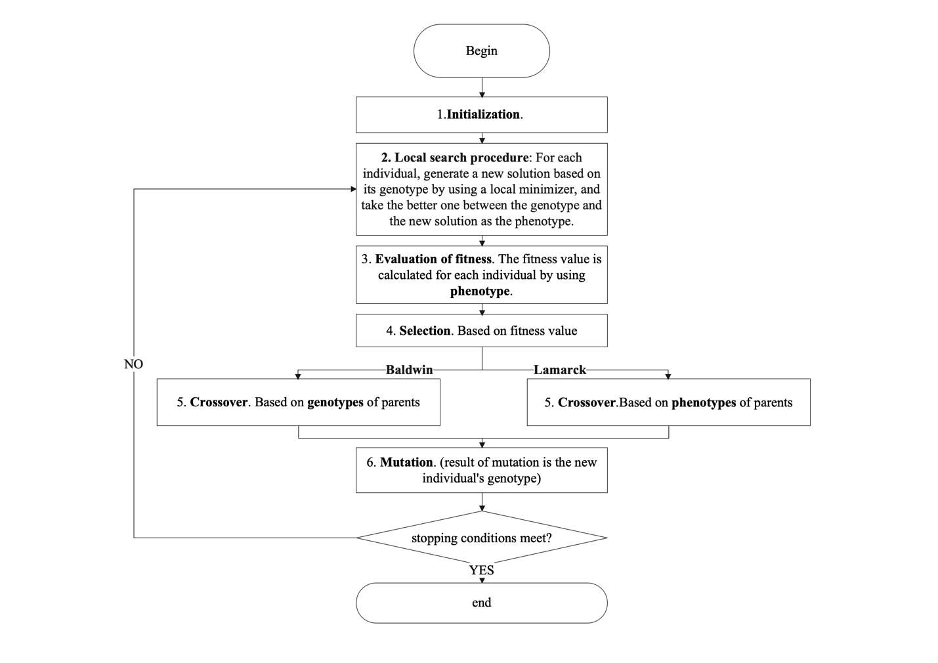

The following are the parameters of the Baldwin and Lamarck algorithm.

**Parameters for Baldwin and Lamarck algorithm**

**Input**: parameter combination

1. max iterations
2. convergence tolerance and
3. fitness function ,number of dimensions of is domain of is [-,-]
4. mutation rate crossover rate
5. mutation type crossover type
6. number of individuals
7. search radius
8. global minimaand threshold
9. local search rate
10. local search type
11. number of local search solutions
12. mode or

**Output**: best solution

The following **Pseudocode2** shows pseudo-code of Baldwin and Lamarck algorithm. Compared to SSGA, Baldwin and Lamarck algorithm algorithms have an additional local search procedure and a slight difference in the crossover operation, but the rest is the same as SSGA, so no repeat explanation will be given here.

**PseudoCode2**

(1)initialization of the population (number of individuals , number of dimensions of , domain of is [,-])

Save all the individuals in the population

**(2) local search procedure** (local search rate , local search type , number of local search solutions , population , fitness function , domain of is [-,-], search radius )

For to do:

Get genotype of individual in population

For to do:

For to do:

Generate a random probability

if > local search rate :

remains the same

Continue to next dimension

else:

if local search type = “uniform”:

= + ( is generated by uniform distribution [-3*R*-]), 3*R*-]))

=

*=*

end

if local search type = “normal”:

= + ( is generated by normal distribution [MEAN = 0, STD =R*-]))

=

=

end

end

end

save one new solution to list

end

calculate fitness values using fitness function for genotype and new solutions

choose the best one as the phenotype of individual

end

(3) evaluation of the fitness value and similarity for the population **(**population , fitness function )

Based on individuals’ phenotypes.

(4) checking stopping conditions (max iterations , tolerance and , global minimaand threshold )

(5) selection

**(6) crossover operation (crossover rate , crossover type , mode or )**

If mode = “Baldwin”:

Choose parents’ genotypes to do crossover operation

end

If mode = “Lamarck”:

Choose parents’ phenotypes to do crossover operation

end

(7) mutation operation (crossover results, mutation rate , mutation type , search radius )

(8) go to step (2) and generate a phenotype for new individual then begin next iteration

### Local search procedure

Roughly speaking, the local search procedure is implemented in the same way as mutation, i.e., a random number generated by uniform distribution or normal distribution is added to a dimension with a certain probability.

The main differences between the two are as follows:

1. The two occur in different stages. The mutation operation comes after the crossover operation and local search procedure follows the mutation operation.
2. The two produce different numbers of new solutions. Mutation operation will produce only one new solution, which will serve as the genotype of the new individual, whether or not it is better. However, the local search procedure can generate many new solutions, from which the best one is selected and compared with the genotype, and the better one of the best one of new solutions and the genotype is eventually determined as the phenotype of the new individual.
3. The mutation rate and the local search rate can also be different.

# Results

## Best 20 parameter combinations

We find the best 20 parameter combinations by using grid search. First, we propose 200 parameter combinations with different values in iterations, mutation rate, crossover rate, number of individuals, and search radius R. Considering that we have 3 crossover types and 2 mutation types, thus we have 6 combinations of mutation type and crossover type. Then we run 200 parameter combinations for each combination of mutation type and crossover type using SSGA. So, in total we end up with 1200 parameter combinations.

Suppose that is the index of a parameter combination, belongs to .. represents a function where can be . represents the final outcome produced by a specific function and a specific parameter combination. represents the ranking for . For example, if produce the smallest solution among all , then ranked 1st and =1.

represents the performance of a parameter combination for 6 functions.

Considering the time cost, we only used 6 functions. The smaller the score is, the better. Table 2 shows the best parameter combinations for SSGA. The letters in the table 2 header represent, in order, index of a parameter combination , max iterations , mutation rate , number of individuals , crossover rate , mutation type crossover type , search radius , convergence tolerance in continuous iterations, the threshold for finding global optimal value.

Table 2 best 20 parameter combinations for SSGA

|  |  |  |  |  |  |  |  |  |  |  |
| --- | --- | --- | --- | --- | --- | --- | --- | --- | --- | --- |
|  |  |  |  |  |  |  |  |  |  |  |
| 590 | 1000000 | 2/dim | 100 | 0.5 | Normal | Probabilistic crossover | 0.1 | 0.0001 | 3000 | 0.0001 |
| 593 | 1000000 | 2/dim | 100 | 0.5 | Normal | Probabilistic crossover | 0.1 | 0.0001 | 3000 | 0.0001 |
| 579 | 1000000 | 1/dim | 200 | 0.6 | Normal | Probabilistic crossover | 0.1 | 0.0001 | 3000 | 0.0001 |
| 588 | 1000000 | 2/dim | 100 | 0.6 | Normal | Probabilistic crossover | 0.1 | 0.0001 | 3000 | 0.0001 |
| 589 | 1000000 | 2/dim | 100 | 0.7 | Normal | Probabilistic crossover | 0.1 | 0.0001 | 3000 | 0.0001 |
| 591 | 1000000 | 2/dim | 100 | 0.6 | Normal | Probabilistic crossover | 0.1 | 0.0001 | 3000 | 0.0001 |
| 576 | 1000000 | 1/dim | 200 | 0.6 | Normal | Probabilistic crossover | 0.1 | 0.0001 | 3000 | 0.0001 |
| 587 | 1000000 | 2/dim | 100 | 0.5 | Normal | Probabilistic crossover | 0.1 | 0.0001 | 3000 | 0.0001 |
| 569 | 1000000 | 1/dim | 200 | 0.5 | Normal | Probabilistic crossover | 0.1 | 0.0001 | 3000 | 0.0001 |
| 558 | 1000000 | 1/dim | 100 | 0.6 | Normal | Probabilistic crossover | 0.1 | 0.0001 | 3000 | 0.0001 |
| 592 | 1000000 | 2/dim | 100 | 0.7 | Normal | Probabilistic crossover | 0.1 | 0.0001 | 3000 | 0.0001 |
| 572 | 1000000 | 1/dim | 200 | 0.5 | Normal | Probabilistic crossover | 0.1 | 0.0001 | 3000 | 0.0001 |
| 594 | 1000000 | 2/dim | 100 | 0.6 | Normal | Probabilistic crossover | 0.1 | 0.0001 | 3000 | 0.0001 |
| 542 | 1000000 | 0.5/dim | 200 | 0.5 | Normal | Probabilistic crossover | 0.1 | 0.0001 | 3000 | 0.0001 |
| 570 | 1000000 | 1/dim | 200 | 0.6 | Normal | Probabilistic crossover | 0.1 | 0.0001 | 3000 | 0.0001 |
| 562 | 1000000 | 1/dim | 100 | 0.7 | Normal | Probabilistic crossover | 0.1 | 0.0001 | 3000 | 0.0001 |
| 575 | 1000000 | 1/dim | 200 | 0.5 | Normal | Probabilistic crossover | 0.1 | 0.0001 | 3000 | 0.0001 |
| 573 | 1000000 | 1/dim | 200 | 0.6 | Normal | Probabilistic crossover | 0.1 | 0.0001 | 3000 | 0.0001 |
| 552 | 1000000 | 1/dim | 100 | 0.6 | Normal | Probabilistic crossover | 0.1 | 0.0001 | 3000 | 0.0001 |
| 555 | 1000000 | 1/dim | 100 | 0.6 | Normal | Probabilistic crossover | 0.1 | 0.0001 | 3000 | 0.0001 |

The parameter about local search procedure for Lamarck and Baldwin are proposed in table 3, other parameters are the same as table 2. The letters in the table 3 header represent, in order, index of a parameter combination , local search rate , local search type , number of local search solutions *, mode or .*

Table 3 parameters for local search procedure

|  |  |  |  |  |  |  |  |  |  |
| --- | --- | --- | --- | --- | --- | --- | --- | --- | --- |
|  |  |  |  | Mode |  |  |  |  | Mode |
| 590 | 0.5 | Uniform | 1 | Baldwin/Lamarck | 592 | 0.5 | Uniform | 1 | Baldwin/Lamarck |
| 593 | 0.5 | Uniform | 1 | Baldwin/Lamarck | 572 | 0.5 | Uniform | 1 | Baldwin/Lamarck |
| 579 | 0.5 | Uniform | 1 | Baldwin/Lamarck | 594 | 0.5 | Uniform | 1 | Baldwin/Lamarck |
| 588 | 0.5 | Uniform | 1 | Baldwin/Lamarck | 542 | 0.5 | Uniform | 1 | Baldwin/Lamarck |
| 589 | 0.5 | Uniform | 1 | Baldwin/Lamarck | 570 | 0.5 | Uniform | 1 | Baldwin/Lamarck |
| 591 | 0.5 | Uniform | 1 | Baldwin/Lamarck | 562 | 0.5 | Uniform | 1 | Baldwin/Lamarck |
| 576 | 0.5 | Uniform | 1 | Baldwin/Lamarck | 575 | 0.5 | Uniform | 1 | Baldwin/Lamarck |
| 587 | 0.5 | Uniform | 1 | Baldwin/Lamarck | 573 | 0.5 | Uniform | 1 | Baldwin/Lamarck |
| 569 | 0.5 | Uniform | 1 | Baldwin/Lamarck | 552 | 0.5 | Uniform | 1 | Baldwin/Lamarck |
| 558 | 0.5 | Uniform | 1 | Baldwin/Lamarck | 555 | 0.5 | Uniform | 1 | Baldwin/Lamarck |

## Results of Experiments

### Percentage of finding the global optimal value

We ran 10 times for a parameter combination and a function. The percentage value for a parameter combination and a function is calculated as (number of times finding the global optimal value of the function /10). We have 20 parameter combinations, so we have 20 percentage values for each function.

Figure 6 has three sub-pictures from top to bottom showing the bar plots distinguished by each function for percentage values produced by 20 parameter combinations for the SSGA, Baldwin and Lamarck algorithms respectively. Each bar in Figure 6 is generated by 20 data points. The number on the blue rectangle is the height of the blue rectangle, also known as mean probability. The mean probability is the mean of the percentage values produced by 20 parameter combinations. The black vertical lines that dive into the blue rectangle is called error bars. The length of the error bars in Figure 6 represents that confidence interval = 95%.

### Confidence Interval Error Bars

Error bars usually consist of four categories. First one is range which is amount of spread between the extremes of the data (i.e., the maximum value minus the minimum value). Second is standard deviation (SD), which is calculated as the square root of the variance. SD can be used to measure the stability of whole data points. Third one is standard error (SE), which is calculated as (SD/number of data points). The fourth one is confidence interval, which is calculated as , wherein is mean of all data points, is chosen -value, is number of data points and SD. With a 95% confidence interval, the chance to be wrong is 5%. [28] If the 95% confidence intervals of two different groups do not overlap, then they are considered statistically significantly different from each other. Conversely, no significant difference between the two groups [29-31]. But the absence of significant differences does not mean that no differences exist [32].

### Analysis

First, we can have a look at SSGA subpicture in Figure 6. The mean probabilities for SSGA finding global optimal values of F1, F2, F3, F4, F6, F7, F9, F10, F11, F12, F13, F14, F16, F17 and F18 is 100%. However, SSGA fails to find the minimum values of F5, F8 and F19 at all. For F15, F20, F21, F22 and F23, the mean probability of SSGA finding the global minimum of these five functions is 13%, 47.5%, 31.5%, 48.5%, 51.5%.

Second, in the middle subpicture showing Baldwin algorithm’s results, one can see that the mean probabilities regarding F1, F2, F3, F4, F6, F7, F9, F10, F11, F12, F13, F14, F16, F17, F5, F8 and F19 are the same as SSGA. For F15, F20, F21, F22 and F23, the mean probability of Baldwin finding the global minimum for these five functions is 15.5%, 40.5%, 53.5%, 77.5%, 84.5%.

It is essential to note here that obviously the error bars of Baldwin and the error bars of SSGA do not overlap for F21, F22 and F23, which means that their performance in these three functions is significantly different. Or in other words, compared to SSGA, Baldwin is significantly better on F21, F22 and F23.

The error bars of Baldwin and the error bars of SSGA do overlap on F15 and F20, the performances for Baldwin and SSGA are not significant different, but they remain distinct. The mean probability of Baldwin finding the global optimal values of F15 is 2.5% more than in SSGA while the mean probability of Baldwin finding the global optimal values of F20 is 7% less than in SSGA. Considering that we only did 10 runs for each combination of parameters, these probabilities are only approximations of the true probability. It is highly possible that Baldwin and SSGA are comparable in terms of performance of these two functions.

Third, in the bottom subpicture showing Lamarck algorithm’s results, one can see that the mean probabilities regarding F1, F2, F3, F4, F6, F7, F9, F10, F11, F12, F13, F14, F16, F17, F5, F8 and F19 are the also same as SSGA. For F15, F20, F21, F22 and F23, the mean probabilities of Lamarck finding the global minimum are 23%, 44.5%, 72.5%, 83%, 90.5%, respectively. Compared to mean percentage values of SSGA with 13%, 47.5%, 31.5%, 48.5%, 51.5% on these five functions, Lamarck's algorithm has nearly doubled the percentage except for F20. The difference between the Lamarck algorithm and SSGA is only 3% in the performance of the F20, which is perfectly acceptable.

Based on the above analysis of Figure 6, one can conclude that Baldwin and Lamarck algorithms are remarkably better than SSGA in finding global minimum of multimodal functions with fixed dimensions like F21, F22 and F23. In terms of the performance of the other functions, the proportions between the three of them are almost equal.

Figure 6 Bar plots for percentage values for SSGA, Baldwin and Lamarck algorithms

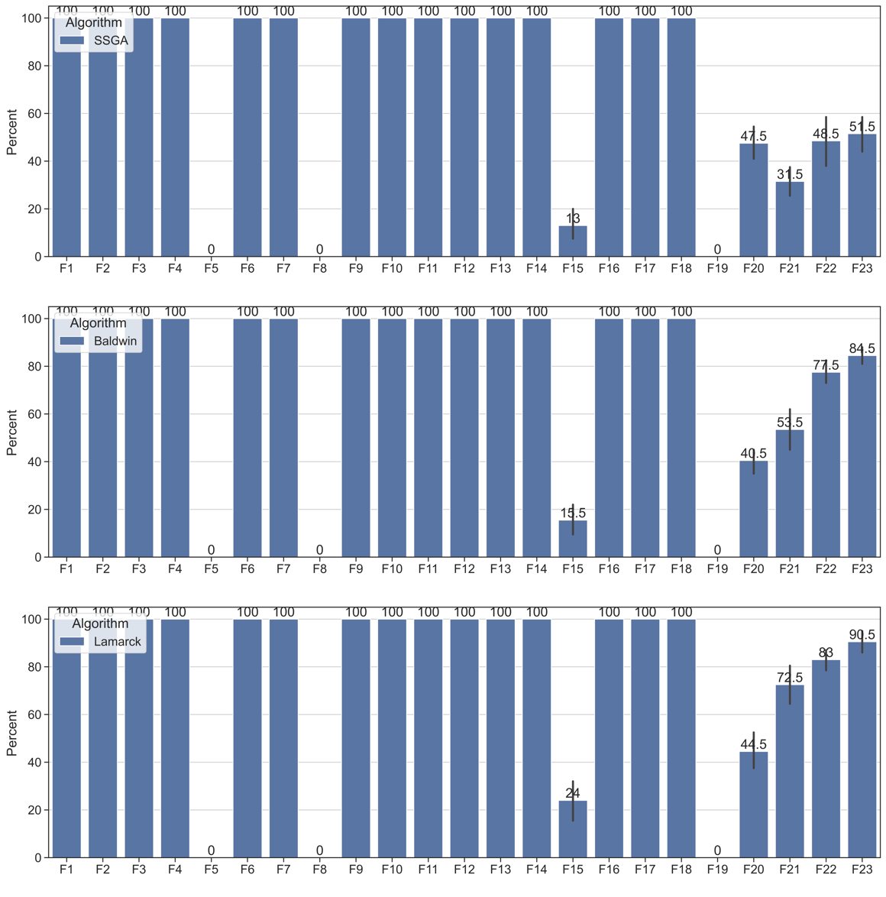

### Improvements between SSGA and Baldwin, Lamarck algorithms

### Violin plots

Figure 7 violin plots for comparing solutions of SSGA, Baldwin, and Lamarck algorithms

A violin plot is designed to provide a visual representation of the distribution of numerical data by using a kernel density estimator, which shows the high peaks in the data. The wider areas of the violin plot represent the higher probability, where many data points are gathered. The wider the area is, the more data points there are. On the contrary, the thinner areas represent the lower probability and less data concentrated here.

Figure 7 shows the violin plots for SSGA, Baldwin and Lamarck algorithms on F15, F20, F21, F22 and F23, respectively. Since all three perform identically on other functions, we will primarily focus on the five functions. Each subplot has a red horizontal line running through it, which represents the position of the global minimum of a function. We have 20 parameter combinations. Each parameter combination was run 10 times for each function. This means that each violin is generated from 200 solutions. The black dots represent the actual solutions. The reason for not seeing so many points on Figure 7 is that many of the solutions are the same.

### Analysis

For F15 and F20, it can be seen that the SSGA, Baldwin and Lamarck algorithms perform almost in equal measure. For F21, F22 and F23, the data points for both the violins of Lamarck and Baldwin algorithms are highly concentrated, and the solutions found by these two algorithms are smaller than those found by SSGA.

### Comparison between Baldwin and Lamarck algorithm

Figure 8 illustrates the violin plots for Baldwin and Lamarck algorithms for each function, using budget data. Budget in this case means the number of times a fitness function is called throughout the process of generating a solution for a function using a parameter combination. It can be seen that on F21, F22 and F23, the budget used by Lamarck's algorithm is significantly lower than that required by Baldwin's algorithm, and virtually no gap is found in the other functions.

Figure 8 violin plots for comparing budgets for Baldwin and Lamarck algorithms

## Conclusion

Based on the Steady-state genetic algorithm (SSGA), this paper extends genetic search with memetic optimization. We offer two valuable versions of memetic optimization: one motivated by the Baldwinian effect, while the other by the Lamarckian theory of evolution, named after Baldwin algorithm and Lamarck algorithm, respectively. Compared to SSGA, Baldwin and Lamarck showed a significant advantage in finding the global minima of multimodal functions with fixed dimensions such as F21, F22 and F23. But the differences in the performance of the other functions are not obvious. Compared to Baldwin, Lamarck's algorithm can find the minimum value of a function using a lower budget. The performance of both Baldwin and Lamarck algorithms is evaluated and validated on benchmark functions CEC-BC-2017.

# Reference

1. Wikipedia Contributors (2019). *Genetic algorithm*. [online] Wikipedia. Available at: https://en.wikipedia.org/wiki/Genetic_algorithm.
2. Katoch, S., Chauhan, S.S. and Kumar, V. (2020). A review on genetic algorithm: past, present, and future. *Multimedia Tools and Applications*. doi:10.1007/s11042-020-10139-6.
3. Mirjalili, S. (2019). Genetic Algorithm. In: Evolutionary Algorithms and Neural Networks. Studies in Computational Intelligence, vol 780. Springer, Cham. https://doi.org/10.1007/978-3-319-93025-1_4
4. Collins, R. J., & Jefferson, D. R. (1991). Selection in massively parallel genetic algorithms (pp. 249–256). University of California (Los Angeles), Computer Science Department.
5. Ishibuchi, H., & Yamamoto, T. (2004). Fuzzy rule selection by multi-objective genetic local search algorithms and rule evaluation measures in data mining. *Fuzzy Sets and Systems*, *141*(1), 59–88.
6. Hutter, M. (2002). Fitness uniform selection to preserve genetic diversity. In Proceedings of the 2002 Congress on Evolutionary Computation, CEC’02 (Vol. 1, pp. 783–788). IEEE.
7. Grefenstette, J. J. (1989). How genetic algorithms work: A critical look at implicit parallelism. In *Proceedings of the 3rd International Joint Conference on Genetic Algorithms (ICGA89)*.
8. Syswerda, G. (1989). Uniform crossover in genetic algorithms. In *Proceedings of the Third International Conference on Genetic Algorithms* (pp. 2–9). Morgan Kaufmann Publishers.
9. Semenkin, E., &Semenkina, M. (2012). Self-configuring genetic algorithm with modified uniform crossover operator. In International Conference in Swarm Intelligence (pp. 414-421). Heidelberg: Springer.
10. Hu, X. B., & Di Paolo, E. (2007). An efficient genetic algorithm with uniform crossover for the multi-objective airport gate assignment problem. In IEEE Congress on Evolutionary Computation, 2007 (CEC 2007) (pp. 55-62). IEEE.
11. Tsutsui, S., Yamamura, M., & Higuchi, T. (1999). Multi-parent recombination with simplex crossover in real coded genetic algorithms. In Proceedings of the 1st Annual Conference on Genetic and Evolutionary Computation-Volume 1 (pp. 657-664). Morgan Kaufmann Publishers Inc.
12. Bck, T., Fogel, D. B., & Michalewicz, Z. (Eds.). (2000). Evolutionary computation 1: Basic algorithms and operators (Vol. 1). CRC press.
13. Oliver, I. M., Smith, D., & Holland, J. R. (1987). Study of permutation crossover operators on the travelling salesman problem. In Proceedings of the Second International Conference on Genetic Algorithms and their Applications, July 28-31, 1987 at the Massachusetts Institute of Technology, Cambridge, MA. Hillsdale, NJ: L. Erlhaum Associates.
14. Davis, L. (1985). Applying adaptive algorithms to epistatic domains. In IJCAI (Vol. 85, pp. 162-164).
15. Whitley, D., Timothy, S., & Daniel, S. Schedule optimization using genetic algorithms. In D. Lawrence (Ed.) 351-357.
16. Hinterding, R. (1995). Gaussian mutation and self-adaption for numeric genetic algorithms. In *IEEE International Conference on Evolutionary Computation* (Vol. 1, p. 384). IEEE.
17. Tsutsui, S., & Fujimoto, Y. (1993). Forking genetic algorithm with blocking and shrinking modes (fGA). In *ICGA* (pp. 206–215).
18. Oosthuizen, G. D. (1987). Supergran: A connectionist approach to learning, integrating genetic algorithms and graph induction. In *Proceedings of the second International Conference on Genetic Algorithms and their Applications*, July 28–31, 1987 at the Massachusetts Institute of Technology, Cambridge, MA. Hillsdale, NJ: L. Erlhaum Associates.
19. Mauldin, M. L. (1984). Maintaining diversity in genetic search. In *AAAI* (pp. 247–250).
20. Ankenbrandt, C. A. (1991). An extension to the theory of convergence and a proof of the time complexity of genetic algorithms. In *Foundations of genetic algorithms* (Vol. 1, pp. 53–68). Elsevier.
21. Wikipedia Contributors (2019). Memetic algorithm. [online] Wikipedia. Available at: https://en.wikipedia.org/wiki/Memetic_algorithm.
22. Radcliffe, Nicholas J., and Patrick D. Surry. “Formal Memetic Algorithms.” Evolutionary Computing, 1994, pp. 1–16, 10.1007/3-540-58483-8_1. Accessed 22 Nov. 2022.
23. Dutta, Priyom & Mahanand, B.S.. (2022). Affordable energy-intensive routing using metaheuristics. 10.1016/B978-0-323-85117-6.00013-3.
24. ‌ García-Martínez, Carlos, and Manuel Lozano. "Local search based on genetic algorithms." Advances in metaheuristics for hard optimization. Springer, Berlin, Heidelberg, 2007. 199-221.
25. Wikimedia Foundation. (2022, November 21). *Genotype*. Wikipedia. Retrieved November 22, 2022, from https://en.wikipedia.org/wiki/Genotype
26. *Phenotype* (2022) *Wikipedia*. Wikimedia Foundation. Available at: https://en.wikipedia.org/wiki/Phenotype (Accessed: November 22, 2022).
27. <https://doi.org/10.48550/arXiv.cs/0212036>